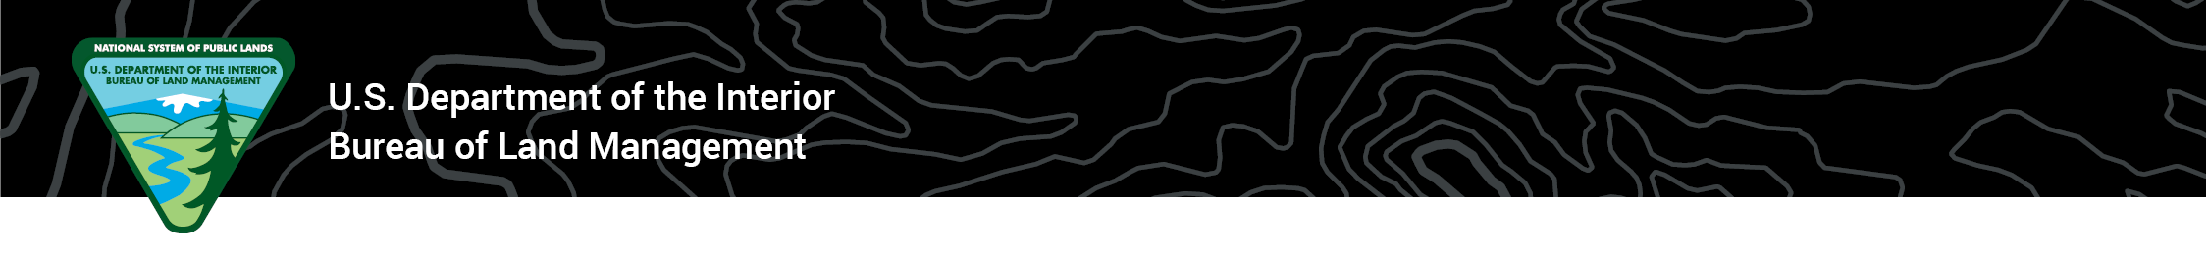 **Announcement**Grand Junction Field Office

**Media Contact:** Heather Marsh, Public Affairs, [hmarsh@blm.gov](mailto:hmarsh@blm.gov), 970-852-9272

Aug. 23, 2024

**BLM proposes new fees for Dominguez-Escalante National Conservation Area**

**GRAND JUNCTION, Colo.** — The Grand Junction Field Office seeks public input on a business plan with proposed recreation fees for select campsites in the Dominguez-Escalante National Conservation Area. The field office will accept comments from the public through Sept. 23.

“We want people who chose to recreate in the Dominguez-Escalante NCA to have quality outdoor experiences,” said **Stacey Colón, Grand Junction Field Office Manager**. “The proposed fees will go toward maintaining the recreation sites where they are collected and protecting public lands for everyone’s enjoyment today and in the future.”

Funds from the fees will help pay for expenses such as campsite improvements, new site developments, law enforcement services, and increased campground operating costs.

One proposed fee is an expanded amenity fee and covers the use of campsites with features like tent spaces, drinking water, toilet facilities, and road access. The fee for one campsite is $20 per night and includes two vehicles. At larger campsites, each additional vehicle beyond the first two will cost $10 each.

The other fee is for an [individual special recreation permit](https://www.blm.gov/programs/recreation/permits-and-fees) that covers overnight use in designated areas of the [Gunnison River in the NCA between Delta and the Whitewater](https://eplanning.blm.gov/public_projects/2016450/200555195/20080209/250086391/DE-GunnisonRiver_Overview_Landscape.pdf). Permits will cost $20 per night for small groups, $50 per night for medium groups, and $100 per night for large groups. For group size descriptions, see the business plan.

BLM will not require fees for day use or dispersed/undeveloped camping areas in the NCA. Full details of the proposed fees and complete business plan are available on the [BLM website](https://www.blm.gov/sites/default/files/docs/2024-06/508_20240625%20D-E%20NCA%20Business%20Plan%20%281%29.pdf).

Send comments via email to [BLM_CO_GJ_Web_Mail@blm.gov](https://doimspp-my.sharepoint.com/personal/hmarsh_blm_gov/Documents/PA%20Docs/GJFO/BLM_CO_GJ_Web_Mail@blm.gov).

-BLM-

The BLM manages more than 245 million acres of public land located primarily in 12 western states, including Alaska, on behalf of the American people. The BLM also administers 700 million acres of sub-surface mineral estate throughout the nation. Our mission is to sustain the health, diversity, and productivity of America’s public lands for the use and enjoyment of present and future generations.