Announcement
Upper Colorado River District
Media Contact: Heather Marsh, Public Affairs, hmarsh@blm.gov, 970-852-9272
June 27, 2024

BLM welcomes new Grand Junction Field Office manager

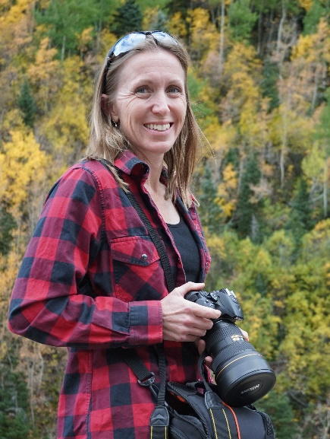
GRAND JUNCTION, Colo. — The Bureau of Land Management Upper Colorado River District welcomes Stacey Colón as the new field manager for the Grand Junction Field Office. Colón will transition from her current position to field manager June 30.

As field manager, Colón will be responsible for the management and stewardship of more than 35 permanent employees and more than 1.2 million acres of public land surrounding the Western Slope’s largest population center.

“We are thrilled Stacey was selected for her new position and will remain part of BLM Colorado,” said Upper Colorado River District Manager Greg Larson. “A proven leader with diverse management skills and more than 23 years of public service – she is a true asset to our organization and role model for her team.”
Grand Junction Field Office Manager Stacey Colón

Colón is no stranger to BLM Colorado; she joined the bureau in 2020 and has served in various leadership roles, most recently as the acting field manager of the Grand Junction Field Office.

“I’m grateful for the opportunity to lead the Grand Junction Field Office team, and to work with our partners and the public to meet the challenges of multiple use on our public lands on the Western Slope,” said Colón.

Prior to BLM, Colón spent 20 years in the U.S. Marine Corps, starting out as a pilot and project manager. After earning a master’s degree in environmental policy and management, she served as director of the environmental, safety, and facilities departments on two U.S. Marine Corps installations, where she led the interdisciplinary environmental management, facilities, public works, acquisition and engineering, and safety teams during her last five years in uniform.

Colón lives in Fruita, Colo., with her husband and two sons. Colón and her family spend as much of their free time as possible exploring public lands on the Western Slope and beyond.

-BLM-

The BLM manages more than 245 million acres of public land located primarily in 12 western states, including Alaska, on behalf of the American people. The BLM also administers 700 million acres of sub-surface mineral estate throughout the nation. Our mission is to sustain the health, diversity, and productivity of America’s public lands for the use and enjoyment of present and future generations.

