Online Resources for Migratory Bird Information

Version 2.0

This guide provides a synopsis of online bird resources that you may find useful in your efforts to learn more about birds or implement bird conservation. It is by no means comprehensive but has many helpful links and sources. For convenience, this document is divided into seven sections including Reference Information, Analytical Tools, Databases, Plans and Partnerships, Birding Community Websites and Citizen Science, Education and Outreach and Useful Bird Related Apps. The document was compiled based on the resources many other professionals have found very useful in their work, whether for research, habitat restoration, document writing, public outreach, planning, or inventory and monitoring. Some sites, such as IMBCR, and eBird will be especially useful in information gathering for environmental analysis of project impacts. Still other sites will provide much of the data, natural history, and conservation information needed for providing the background of a sound NEPA analysis. Within the different sites are links to grant programs, educational and outreach tools, citizen science opportunities, and information about current policy related to birds and their habitats.

This list of resources will be updated regularly, and there are likely useful websites that are not listed here but should be. Please feel free to notify Carrie Hugo chugo@blm.gov, Ethan Ellsworth eellsworth@blm.gov, or Paul Makela pmakela@blm.gov for future revisions and updates.

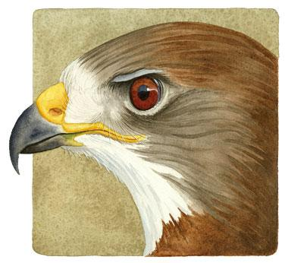
REFERENCE INFORMATION

Birds of the World- https://birdsoftheworld.org/bow/home

This site provides in depth information about the life history of all North American bird species. It is an invaluable resource for conducting NEPA analysis. Not only can you find out the minutia about any bird species, but you can also get citations for further research. Species profiles include photos, maps, and illustrations. Each section of the profile provides information taken from published literature and citations are included. Species accounts are updated as more information becomes available, so this is a dynamic site.

Birds Canada- https://www.birdscanada.org/

This site is almost like a Canadian version of the Cornell website. However, it has some neat interactive mapping features that include bird species distribution data from BBS, CBC, and other sources. The data can be displayed through an interactive map that allows for toggling between various layers including BCR. It has links to interesting articles on conservation issues related to birds, as well
as citizen science projects like Project Feeder Watch. The publication link will give you access to numerous documents that you may find useful- monitoring reports and strategies, survey reports, habitat monitoring publications, and research studies.

Digital Atlas of Idaho- https://digitalatlas.cose.isu.edu/

The Digital Atlas of Idaho Project (DAI) delivers natural history information to a variety of audiences, including K-12 educators, college students, agency personnel, businesses, non-governmental organizations, and the public at large. It contains detailed written descriptions of Idaho's natural history, photographs, maps, sounds, and glossaries. This is a great resource if you are looking for basic natural history information, complemented by geographic locations for a species in Idaho. It provides maps of Idaho wildlife species distribution as well as State Status, State Rank, Global Rank, and National Rank.

Feather Atlas- https://www.fws.gov/Lab/featheratlas/

This is a great resource if you find a flight feather (wing or tail) while out in the field. The image library includes over 250 species in a variety of families.

Flyways- https://www.fws.gov/partner/migratory-bird-program-administrative-flyways
This site was created to incorporate human dimensions into waterfowl management. The site provides updates on surveys, season frameworks, waterfowl identification, history, and harvest information. There is also information on band returns, biologist reports, and press releases. Visitors can query harvest and band return information by species and state.

Idaho Birding Trail- https://idfg.idaho.gov/ibt

This is a great site to refer to when you get inquiries from the public about where to view birds in your office area. It is also a very user-friendly resource for you if you are not that familiar with what birds are in your area. If you need a day away from your desk, find a stop on the bird trail in your vicinity (most likely there is one on BLM in your District or Field Office Area) and go look for birds. There are stops all over the state and the guide provides great information about access and which birds you may find at each stop in a particular time of year.

Idaho Birds- http://www.idahobirds.net/

As the website touts, it’s “Your comprehensive online resource for wild birds and birding in the State of Idaho.” Here you can find links to Regional articles and Big Year Tallies, a photo and video gallery, Rare Bird Reports, and the Official Idaho Birds Checklist. Links to local Audubon Chapters, and latilong maps of species distribution in the state (although they are pretty crude they do give you a visual reference as to which species can be found in which area and at what time of year). There are links to listservs in case you want to subscribe for the latest, up-to-date sightings. Two of the more popular lists are Idaho Birders Linked Electronically (IBLE) and the Inland-Northwest Birders (which covers from about Lewiston north to Canada and eastern Washington.

National Wildlife Health Center- https://www.usgs.gov/national-wildlife-health-center

This site is a great resource for familiarizing yourself with wildlife disease, to learn about current disease outbreaks and mortality events, and to peruse current research in this field. There is Field Manual of Wildlife Diseases, as well as many other resources for contributing to wildlife disease reporting or using existing data on wildlife diseases.

NatureServe Explorer https://explorer.natureserve.org/
NatureServe Explorer is an authoritative source for information on more than 70,000 plants, animals, and ecosystems of the United States and Canada. Explorer includes particularly in-depth coverage for rare and endangered species. It is an excellent place to quickly check the breeding, migration, and nonbreeding ranges for birds. Beware that it has a quirk in the search engine. Do not put an apostrophe in names like MacGillivray’s Warbler or you will get an error - just enter MacGillivrays Warbler.

North American Marsh Bird Monitoring Program- https://cales.arizona.edu/research/azfwru/NationalMarshBird/

This program was designed to develop and beta-test standardized protocols to be used in a national or continental monitoring effort. The specific goal of the program at this time is to develop and field-test monitoring protocols that will eventually be used in a national monitoring effort. Here you can find
information about Focal Species along with their vocalizations. Field methods are also described and you can download protocols, data sheets, and habitat measurement methodologies. Publications are also listed and available for download.

Searchable Ornithological Research Archive (SORA)- https://sora.unm.edu/

This site provides access to research articles from 13 bird journals all the way back to 1884 (Auk)! The most recent volumes are not available for all publications, but this is still a superb place to find many articles fast.

ANALYTICAL TOOLS

Avian Knowledge Network http://www.avianknowledge.net/

The Avian Knowledge Network (AKN) is a partnership of people, institutions and government agencies supporting the conservation of birds and their habitats based on data, the adaptive management paradigm, and the best available science. AKN partners act to improve awareness, purpose, access to, and use of data and tools at scales ranging from individual locations to administrative regions (e.g., management areas, states, countries) and species ranges. This site has access to mind boggling amounts of data that you can explore just for kicks or use to write a Master’s Thesis. With tools for researchers, educators, managers, and citizen scientists you can find almost anything about birds where data is concerned. You can also contribute your own data. Databases are
organized into “Nodes”, and there is now a Federal Avian Data Center Node. You can access it here: https://data.pointblue.org/partners/fedadc/

All available AKN Nodes can be accessed from this page:
http://avianknowledge.net/index.php/akn-nodes/

Boreal Avian Modeling Project-https://borealbirds.ualberta.ca/

This website focuses on the abundance, distribution, and habitats of boreal birds in Canada, many of which pass through the U.S. as they migrate. Using quantitative modeling techniques, and a comprehensive data set from numerous projects across North America, the site provides tools for the evaluation and assessment of the effects on human activity on boreal birds. You can conduct a search for any boreal forest species and get population and density estimates, distribution, life history, and habitat associations.

Integrated Monitoring in Bird Conservation Regions (IMBCR)-

http://rmbo.org/v3/avian/Projects/IntegratedMonitoringinBirdConservationRegions.aspx

The IMBCR program involves a spatially balanced, statistically rigorous sample design for bird monitoring, involving a broad network of federal, state and NGO partners. These include (but are not limited to) the BLM, U.S. Forest Service, National Park Service, state wildlife agencies and other organizations such as the Avian Science Center, Intermountain Bird Observatory, and the Wyoming Natural Diversity Database. Data can be used for population trend analyses at various scales, as well as to ascertain occupancy and associated habitat information to inform conservation planning, NEPA and other purposes. Because rare birds might not be picked up by IMBCR survey methods, you might want to supplement this information with eBird or Breeding Bird Survey data. This site, hosted by the Rocky Mountain Avian Data Center, summarizes the program, provides links to annual reports, and access to IMBCR data (see “Explore the Data” tab).

IPAC- https://ecos.fws.gov/ipac/

IPAC is an interactive tool that enables the user to see if any listed species, critical habitat, migratory birds, or other natural resources may be impacted by a project. Use the map tool to determine if there are other resources in a project location, such as wetlands, wildlife refuges, GAP land cover, and other important biological resources. This tool also enables the user to get a list of possible impacts and access conservation measures that may reduce them.

Partners in Flight Landbird Conservation Plan-https://www.partnersinflight.org/resources/the-plan/

According to the website, this 2016 Plan Revision documents widespread declines in populations of many of the 448 species of landbirds in the U.S. and Canada. The Plan also profiles species of greatest concern as well as threats and extinction risk assessments, regional species of continental importance, and strategies for implementing conservation.

Partners in Flight- Land bird Population Estimate Database- https://pif.birdconservancy.org/
This database allows you to get population estimates for land birds by State, Bird Conservation Region (BCR), or the portion of the BCR in a specific state (i.e. the Idaho portion of BCR 10). As an example, the estimated population for Mountain Bluebirds (our State Bird) in the Idaho portion of BCR 10 is 40,000 and this represents 0.8% of the global population.

Partners in Flight Species Assessment Database- https://pif.birdconservancy.org/

This site provides a vulnerability assessment for all the landbird species in the U.S., Canada, and Mexico. Each species is scored on six factors that contribute to the future vulnerability of the species – population size, population trend, size of the breeding and non-breeding ranges, and threats during the breeding and nonbreeding season. The assessment also provides a summary of statistics for the species including estimated population size, percentage of the population that breeds within a BCR, Region, or Country, and population trends for the species. Be sure to take a look at the Avian Conservation Assessment Database Handbook for help interpreting the tables. (http://pif.birdconservancy.org/acad.handbook.pdf). You can also access the Partners In Flight Population Estimate Database at the above link. This database can be very useful to determine what portion of a species population may be affected by a proposed project.

DATABASES

Avian Knowledge Network- https://avianknowledge.net/

This site provides one-stop shopping for some of the more enormous nationwide data sets. Bird observations from eBird reference data, Project Feeder Watch, Christmas Bird Counts, Breeding Bird
Surveys and more can all be downloaded for your use. Be forewarned that some of the data sets are quite large! But if you need to have the actual data in your own hands to manipulate for your analysis needs, this would be the site to go to. This could be useful if you prefer to make custom maps or a smaller scale analysis for bird observations in relationship to habitat projects, habitat changes, time of year etc.

Breeding Bird Survey data- https://www.pwrc.usgs.gov/bbs/results/

The North American Breeding Bird Survey (BBS) was initiated in 1966 and has since become one of the most systematically collected data sets for nationwide breeding birds. As opposed to nationwide monitoring efforts like the Christmas Bird Count and Project Feeder Watch, the BBS is conducted by experienced birders and professionals in a consistent fashion. The result is a high quality, long-term data set for breeding birds in North America. Trends for different regions of North America or specific species can be analyzed with the understanding that lack of BBS routes in an area make drawing conclusions more difficult. Check out the maps of the BBS routes and see how many there are in your
area. Some may travel right through your district or project site. You can query the database and download or copy BBS data for your own use.

Christmas Bird Count data- http://netapp.audubon.org/cbcobservation/

The Christmas Bird Count is the longest running Citizen Science Survey in the world (119 years and no end in sight). Each year bird enthusiasts record every bird they see and hear within a 15-mile diameter circle. These circles are the same every year and surveys have to be conducted between December 14th and January 5th. In 2018, 2568 counts were conducted, documenting 48,399,044 birds. Anyone can do the Christmas Bird Count, but they have to submit their observations to the “Compiler” for their Circle. This link will allow you to explore the CBC data for your state or region. The beauty of the CBC is that it provides data on resident bird species in the non-breeding season. This is a great tool for looking at which species are using a particular area in the winter. Because there are more people participating

in the CBC each year, the numbers are standardized by calculating the number of observations for a species per “party hour”. This eliminates the bias resulting from more eyes out there observing more birds. In 1957 in Idaho, 0.143 collared doves/party hour were recorded during the CBC. In 2011, 2.9272 Collared Doves/party hour were recorded, that’s a 20-fold increase.

eBird- http://ebird.org/content/ebird

eBird is a site where anyone can provide species observation data which are then compiled and managed by the Cornell Lab of Ornithology. It is a great resource for species occurrence maps and very useful to see if there are observations for a specific species in or near a project area. Over 100 million sightings have been submitted! Some may question the integrity of the data because anyone can submit their information to eBird. However, any sightings that are out of the ordinary require more
information from the observer before they are accepted. Also, the sheer volume of observations tends to overcome any small errors that might make it through the quality checks. One really fun part of the site to explore is the animated species occurrence maps. You can click on a species of interest and an animated map with the species occurrence throughout the year comes up. They are really interesting and great for illustrating the process of migration to the public. Here are the Bullock’s Oriole and the Barn Swallow maps.

https://ebird.org/science/status-and-trends/bulori
https://ebird.org/science/status-and-trends/barswa

You can also query the eBird database by county to find out which species occur throughout the year in a geographic area. In the “explore data” section you can query any North American species and get a map showing observation locations. By clicking in the individual observation, you can get the date the sighting was made and who submitted it. This could be very useful to see if a species has been documented by birders in a potential BLM project area.

Idaho Department of Fish and Game Species Diversity Database https://idfg.idaho.gov/species/

The Idaho Species Diversity Database is the most comprehensive repository for site-specific data on Idaho’s fish, wildlife, and plant diversity. This database is maintained by the Idaho Fish and Wildlife Information System under the stewardship of the Wildlife Diversity Program at the Idaho Department of Fish and Game. Observations are contributed by partners in federal agencies, state agencies, tribes, non-governmental organizations, private consultants, and others. At this site, you can query by species and view agency status, Idaho observations, modeled species distribution, links to additional information and more.

Idaho Department of Fish and Game Special Status Species Data Exports-

Idaho BLM, as a partner, receives biannual Special Status Species data exports from the Idaho Department of Fish and Game. Since the location of geospatial data may change over time, work through your local GIS Specialist as needed to determine the current path to the data.

Midwinter Bald Eagle Count- https://corpslakes.erdc.dren.mil/employees/bird/midwinter.cfm

The Midwinter Bald Eagle Survey takes place during the first two weeks of January each year. The U.S. Army Corps of Engineers (USACE) coordinates the Midwinter Bald Eagle Survey, in which several hundred individual surveyors count eagles along standard, non-overlapping survey routes. This site provides access to results of Midwinter Bald Eagle Surveys conducted from 1986-2005 along 746 routes in 43 states. You can retrieve raw count data as well as summary information (trends, means, high and low counts) for survey routes. You can search for survey routes by state, map location, drainage/survey route name, or geographic (latitude and longitude). You can retrieve
summaries for one route at a time or for multiple routes. An interactive help program will walk you through the steps.

Project FeederWatch (http://www.birds.cornell.edu/pfw/)
Project FeederWatch is a winter-long survey of birds that visit feeders at backyards, nature centers, community areas, and other locales in North America. FeederWatchers periodically count the birds they see at their feeders from November through early April and send their counts to Project FeederWatch. FeederWatch data help scientists track large scale movements of winter bird populations and long-term trends in bird distribution and abundance. Like the Christmas Bird Count, it provides extremely useful data on birds in winter.

Raptor Population Index- http://www.rpi-project.org/

This site provides data from multiple partners at multiple sites around the country where migrating raptors are monitored. While it does not include any sites in Idaho, nearby sites include Chelan Ridge in WA, the Goshute Mountains in NV, and the Bridger Mountains in MT. You can query the data by species and get the information in graph or map format. There are also Regional Species Assessments and a clearinghouse of publications relevant to raptor populations.

The Institute for Bird Populations- https://www.birdpop.org/pages/programs.php

The Institute for Bird Populations is dedicated to research and dissemination of information on the abundance, distribution, and ecology of birds, and to facilitating scientifically informed conservation of birds and their habitats. Their website provides publications and access to data for several programs of research. Those likely to be most relevant to you are: MAPS (Monitoring Avian Productivity and Survival), Avian Inventory Program, MAWS (Monitoring Avian Winter Survival-temperate North America banding data), and MoSI (Monitoreo de Sobrevivencia Invernal- neotropical banding data). IBP also leads the way in analyzing the effects of large-scale climate events, such as El Nino, on long-term bird population trends.

PLANS AND PARTNERSHIPS

American Bird Conservancy-https://abcbirds.org/
ABC is the only U.S.-based group with a major focus on bird habitat conservation throughout the entire Americas. ABC acts across the full spectrum of threats to birds to safeguard the rarest bird species, restore habitats, and reduce threats, unifying and strengthening the bird conservation movement. The "Mortality Threats to Birds" section (https://abcbirds.org/threats/) has useful statistics and conservation actions for reducing impacts from collisions, cats, wind power development and other issues.

American Kestrel Partnership- http://kestrel.peregrinefund.org/

The American Kestrel Partnership was created in response to long-term declines in kestrel populations in North America. Via the site, users can provide information and observations from registered kestrel nest boxes. Species life history and links to plans for building and monitoring nest boxes, and data sheets are also available. This might be a great Watchable Wildlife Project for local schools, organizations, or volunteers in your District or Field Office Area.

Bird Conservancy of the Rockies- https://birdconservancy.org

BCR is a science- based bird conservation organization that conducts inventory, research, monitoring, and educational programs. Their website has tons of information- from databases (including IMBCR), to publications, to inventory and monitoring protocols. This organization is highly engaged in bird conservation and conducts some of the most relevant and timely research in the Rocky Mountain Region.

Department of Defense Partners in Flight- https://www.denix.osd.mil/dodpif/

This website is dedicated to the special effort between PIF and military installations to manage avian habitat and population while maintaining functionality of U.S. military training bases and facilities in the western hemisphere. It has many similar links to Regional PIF websites including projects, working groups, installation information, and resources.

Department of Energy Wind Program- https://www4.eere.energy.gov/wind/resource_center/

This comprehensive website provides in-depth information related to wind energy. Among other things, there is a link to Wind Wildlife Impacts Literature Database (WILD- https://wild.nrel.gov/), links to grant offerings, current research on high profile species like sage grouse and bats. There is also information about the economic impacts of wind energy development, and resources for understanding the various types of wind energy development.

Fatal Light Awareness Program- https://www.flap.org/

The website is dedicated to reducing bird collisions with man-made structures. According to the website, FLAP is “works to safeguard migratory birds in the built environment through education, research, policy development, rescue and recovery.” Here you can find resources for bird friendly building designs, as well as a “collisions mapper” where you can enter or view records of bird collisions.

Great Basin Bird Observatory- http://www.gbbo.org/

While this organization is housed in Nevada, and much of their research, monitoring, and surveying occurs in that state- a lot of what they do and learn applies to many southern Idaho Field Office Areas. Those of you who have Great Basin Ecosystems within your areas are probably already familiar with Great Basin Bird Observatory (GBBO). If not, start by introducing yourself to their website to find all kinds of goodies. You might find the upland habitat assessment protocol and data sheets particularly
useful. Also, the point count protocol and data sheets might come in handy. There are monitoring plans, and conservation plans that might give you great examples of program objectives or language to use in permitting or RMP revisions. They are currently working on decision support tools that are quantitative and will ultimately help land managers make better decisions based on current habitat metrics, species needs, and desired conditions.

Greater Sage-Grouse Resources-

Here you can find links to information about research, monitoring, partnerships, funding opportunities, conservation plans, and policies related to Sage-grouse and the sagebrush ecosystem. Important BLM sites are also included.

BLM Science In Practice Portal- Greater Sage-Grouse section-
https://spp.blm.gov/programs/haf

https://spp.blm.gov/library/subject-guides/sage-grouse

GRSG Annotated Bibliography

https://www.usgs.gov/publications/annotated-bibliography-scientific-research-greater-sage-grouse-published-october-2019

Working Lands for Wildlife
https://www.wlfw.org/

GRIN - Global Raptor Information Network - http://www.globalraptors.org/grin/indexAlt.asp

This site includes species accounts and a searchable bibliography.

Idaho State Wildlife Action Plan- https://idfg.idaho.gov/swap

This guiding document outlines the Species of Greatest Conservation Need for Idaho and is updated about every 10 years. Along with describing the variety of “ecological sections” within the state, the SWAP species accounts also provide distribution and habitat associations, an assessment of threats, and recommended conservation actions.

Intermountain Bird Observatory- https://www.boisestate.edu/ibo/

The Intermountain Bird Observatory (IBO) is a non-profit research unit of Boise State University. Researchers, graduate students, and undergraduate students have conducted numerous songbird, owl, and raptor studies that can be viewed via the “Programs” link on the homepage. Lucky Peak, near Boise, has been a fruitful area for IBO’s banding program for diurnal raptors, songbirds, and owls. Summaries of the data, as well as other publications from research conducted by IBO can be found on the website. You can also get contact information for a visit to their hummingbird, songbird, raptor, and owl banding sites.

Intermountain West Joint Venture- www.iwjv.org

The mission of the Intermountain West Joint Venture (IWJV) is to conserve priority bird habitats through partnership-driven, science-based projects and programs. The IWJV is the largest of 18 U.S. Habitat Joint Ventures, which are collaborative, regional partnerships of government agencies, non-profit organizations, corporations, tribes, and individuals that work to conserve habitat for the benefit of
birds, other wildlife, and people. In a nutshell, the IWJV is a great resource for technical publications, information on projects occurring to benefit birds throughout the west, as possible sources for funding
for the work you want to do for birds in the Western US. Their website features projects and partners doing great things for birds and also provides an overall framework to help achieve population and habitat goals for birds in the west.

Klamath Bird Observatory- https://https://klamathbird.org/

This website, like the above “Observatory” sites, provides links to publications, current projects, and events. Also, you can find links to standardized methods for data gathering, banding workshops, and other training opportunities.

North American Bird Conservation Initiative- http://nabci-us.org/

The US NABCI Committee brings together partners that work across state and country boundaries, and across taxonomic groups at a landscape scale to ensure that North American bird conservation is coordinated at a scale most relevant for the birds we work with. Here you can get information about Bird Conservation Regions, as well as resources and tools for monitoring, partnership and policy information, and links to documents relevant to bird conservation.

Pacific Flyway Council- http://www.pacificflyway.gov/

The Pacific Flyway Council has both game and nongame migratory bird technical committees that provide biological advice to the council. The technical committees are each composed of one biologist
from the public wildlife agency in each state and province in the western United States, Canada, and Mexico. In the U.S., the Pacific Flyway includes Alaska, Arizona, California, Idaho, Nevada, Oregon, Utah, Washington, and those portions of Colorado, Montana, New Mexico, and Wyoming. The PFC website has flyway management plans, contacts, a meeting schedule, and management and monitoring information.

Partners in Flight- http://www.partnersinflight.org/

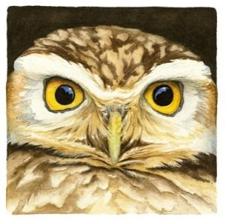
This site provides links to numerous bird related resources and outlines the role of PIF and its relationship to other bird conservation organizations and entities. It also acts as a clearing house for land bird related websites and publications. Links to PIF Regional Working Groups and State and Regional PIF Plans can also be found through this site. If what you are looking for is not on one of the sites listed in this resource guide, the Partners in Flight web page is the next best place to look.

Point Blue Conservation Science- https://www.pointblue.org/

Like other Bird Observatories, Point Blue has contributed invaluable knowledge to our understanding of birds, their habitats, and management. This site has lots of great links to publications, habitat management guides, and citizen science projects. Particularly useful is the link to the California Avian Data Center-http://data.prbo.org/cadc2/ . Here you can get all kinds of information about research, habitat, and citizen science tools. For example, if you are considering conducting “area searches” for birds you can get instructional documents and data forms. If you need a template for habitat metrics at

a nest site, they have it. There are numerous resources that can reduce your work and guide you in efficiently collecting relevant data, developing monitoring programs, or assessing habitat in your area.

Raptor Research Foundation- http://www.raptorresearchfoundation.org/

This website provides a plethora of raptor related information- from aid in raptor ID to a clearinghouse of raptor related research and publications. There is also a nice link to information about what to do if you find an injured raptor.

State of the Birds- http://www.stateofthebirds.org/

The State of the Birds is an annual assessment of U.S. bird populations and their habitats. It is not a document full of statistics and research, it is more a broad overview of how bird populations are doing relative to conservation issues of concern. The State of the Birds for 2011 does a great job at illustrating just how important public lands are to birds-year-round. BLM lands top the list as host to the most bird species. The 2010 report addressed the possible and likely effects of climate change on our Nation’s birds, and which bird communities will be hit the hardest.

U.S. Fish and Wildlife Service Golden Eagle Website

https://www.fws.gov/species/golden-eagle-aquila-chrysaetos

U.S. Fish and Wildlife Service Migratory Birds Website-

https://www.fws.gov/program/migratory-birds

Integrated Waterbird Management and Monitoring- https://iwmmprogram.org/

This landscape-scale program focuses on three guilds of waterbirds during migration and winter: waterfowl, shorebirds, and wading birds, and links management actions to monitoring.

BIRDING COMMUNITY WEBSITES AND CITIZEN SCIENCE

All About Birds and Cornell Lab of Ornithology- http://www.allaboutbirds.org/Page.aspx?pid=1189 http://www.birds.cornell.edu/Page.aspx?pid=1478

These two sites (above) provide some basic bird identification information as well as natural history info. You can also get an idea of National and International conservation issues related to birds and read articles and blogs related to birds and bird conservation.

Western Asio Flammeus Landscape Study (WAFLS)-

https://avianknowledgenorthwest.net/projects/short-eared-owls/

Project WAFLS is an eight state (including Idaho) program, designed and led by IBO research staff to assess the population status, trends, and threats against the short-eared owl. This project engages citizen-scientist volunteers across the west to gather critical survey data, enabling a rigorous assessment of the status of this species. Results directly influence conservation actions by state and federal agencies.

Project FeederWatch (http://www.birds.cornell.edu/pfw/)
Project FeederWatch is a winter-long survey of birds that visit feeders at backyards, nature centers, community areas, and other locales in North America. FeederWatchers periodically count the birds they see at their feeders from November through early April and send their counts to Project FeederWatch. FeederWatch data help scientists track large scale movements of winter bird populations and long-term
trends in bird distribution and abundance. Like the Christmas Bird Count, it provides extremely useful data on birds in winter.

Christmas Bird Count data- http://netapp.audubon.org/cbcobservation/

The Christmas Bird Count is the longest running Citizen Science Survey in the world (119 years and no end in sight). Each year bird enthusiasts record every bird they see and hear within a 15-mile diameter circle. These circles are the same every year and surveys have to be conducted between December 14th and January 5th. In 2018, 2568 counts were conducted, documenting 48,399,044 birds. Anyone can do the Christmas Bird Count, but they have to submit their observations to the “Compiler” for their Circle. This link will allow you to explore the CBC data for your state or region. The beauty of the CBC is that it provides data on resident bird species in the non-breeding season. This is a great tool for looking at which species are using a particular area in the winter. Because there are more people participating in the CBC each year, the numbers are standardized by calculating the number of observations for a species per “party hour”. This eliminates the bias resulting from more eyes out there observing more birds. In 1957 in Idaho, 0.143 collared doves/party hour were recorded during the CBC. In 2011, 2.9272 Collared Doves/party hour were recorded, that’s a 20-fold increase.

EDUCATION AND OUTREACH

Environment for the Americas International Migratory Bird Day Site-
http://www.birdday.org/

Here is a great site to gather ideas for a bird-related event in your area. You can get lots of freebies and also find a catalog of inexpensive bird-related giveaways for an outdoor/bird program you are planning. There are free coloring pages, curricula, posters, and other materials. The “Bird Education Resource Directory” on this site provides a one-stop location for bird education resources. The directory relies on members of the bird conservation community sharing their resources. Please take a moment to add your resources.

Useful Bird Related Apps

Smartphone Field Guides:

- Audubon Birds (Regional and North America)-
- Audubon Owls- this app just covers North American Owls a bit more in depth then the regular bird app. And there is a fun owl call quiz game too.
- iBird- (US, Canada, UK and Ireland, Regional US Versions). There is a lite, pro, and plus version. Lite is free and cost goes up from there based on which version and how large a region you want).
- Sibley eGuide to the Birds of North America
- MERLIN- app that can identity birds by sound and by physical features the input by the user

All Mobile Field Guides are accessible without connectivity and include:
Range Maps, Song Libraries, Physical / Habitat Descriptions, and a Method to log sightings.

Audubon App 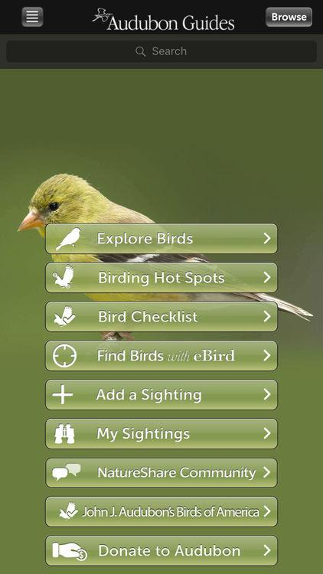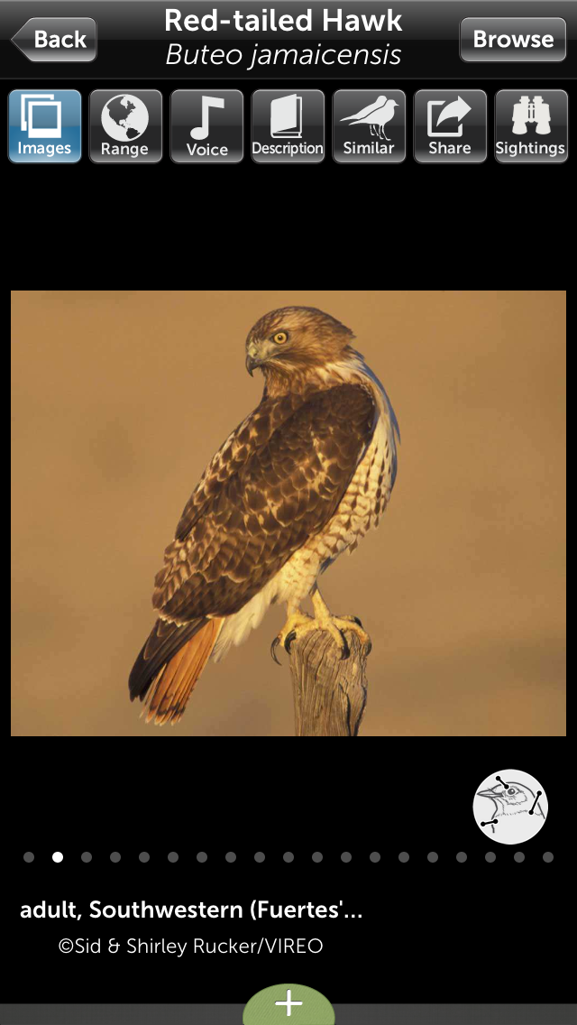

iBird 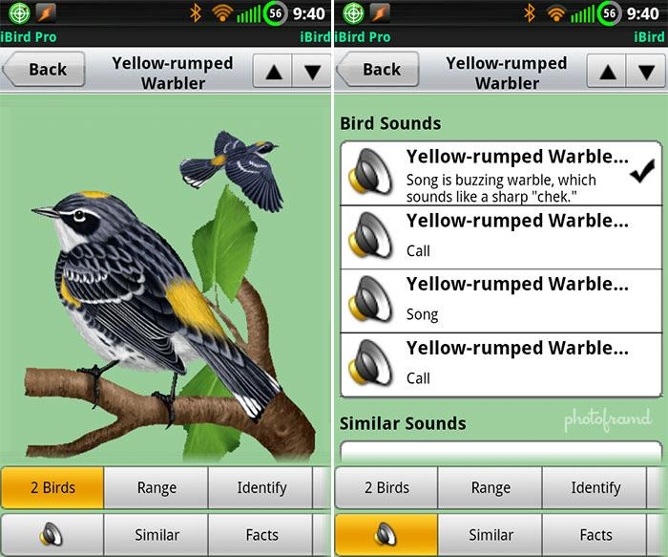

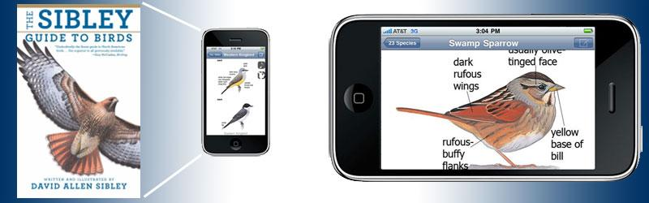

Sibley eGuide

Smartphone Location Based Apps:

BirdsEye- This app is great if you want to keep tabs on what birders are finding in your area. It also travels with you all over North America. So, if you go to training or on a vacation, you can look up what birders are submitting to eBird in that area. It updates very quickly, and you can query notable and rare bird sightings in your area, as well as regular check lists which will include common birds people are seeing as well.

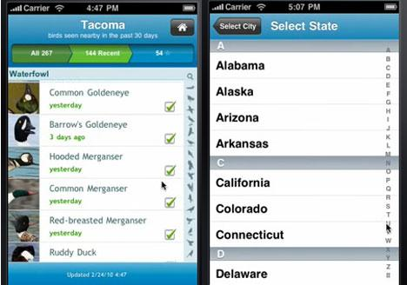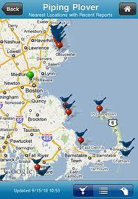

eBird- This app allows you to submit your observations directly to eBird from your smartphone. Even if you don’t have “bars”, if the GPS is working, it will create a checklist based on your location. It will then queue it for submission when you are back in an area with data coverage.





